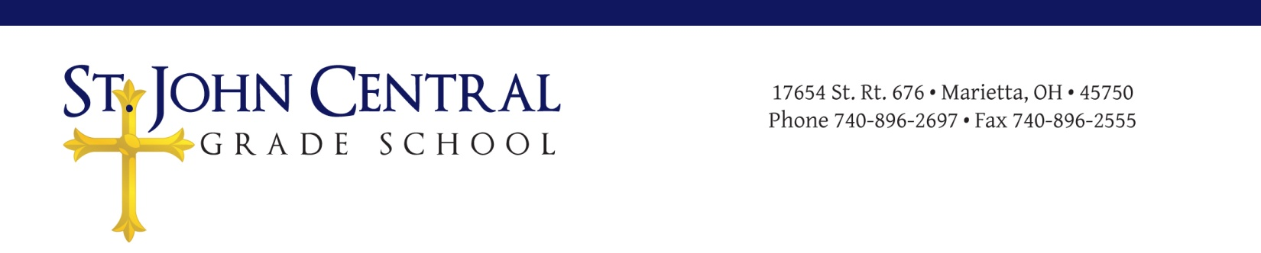

St. John Central Local Educational Advisory Council (LEAC)
Meeting Minutes
February 20, 2018

Call to Order
The meeting was called to order on Tuesday February 20, 2018 at 6:36 p.m. in Mr. Huck’s classroom of St, John Central School with prayer and the Pledge.

Roll Call
Attendees included Evan Schaad, Laura Schott, Ellie Tullius, Kenley Schwendeman, Derek Pottmeyer, Mrs. Tome´, Pam Keeney, Father Davison, and Larry Moegling (Principal).
Public attendees were Ashleigh Pennock, Kristin Pottmeyer, Heather Casto, and Lacey Lauchard.

Approval of Minutes
The organizational meeting minutes of Wednesday January 10, 2018 were approved at 6:39pm.

Public Participation
Ashleigh Pennock presented parent concerns about developing a more established Preschool curriculum. Dr. Moegling suggested forming a preschool committee with Ashleigh Pennock as Chair. Motion was made to establish and empower preschool committee with Ashleigh Pennock as Chair.
Motion: Ellie Tullius
Second: Mrs. Tome´
Vote taken: motion approved 7:09 p.m.
Ashleigh Pennock accepted position as Chair

Ashleigh also expressed groups concerns about 2nd and 3rd grade combined class.

Principal’s Report
Dr. Moegling distributed an agenda for the meeting that briefly discussed the evening’s goals.
- He discussed better use of St. John Central School website for communication.
- Upcoming events on calendar.
- K-8 registration for the 2018-2019 school year.
- Results from the preschool survey and a proposal for a preschool committee (discussed previously in public participation).

LEAC Members’ Report
Derek Pottmeyer-Home and School Report
- No activity. Next meeting 2/21/18.
Mrs. Tome´-Teacher and Staff Report
- Committee working on 2018-2019 school calendar.
- Working on accreditation surveys for grades 4-8.
- Discussed Catholic School Week activities.
- Teachers caught up from snow days.
Pam Keeney-Financial Report
- Nothing to report.
Father Davison-Pastor’s Report
- 2nd grade ready for First Communion

Unfinished Business
Third reading of revised VIP program cover letter and guidelines discussed and will be sent out with survey in Red folder on Friday. Discussed a change to the LEAC constitution. Preschool survey results were previously discussed in public participation. Discussed enrollment and possible marketing strategies to promote St. Johns Central.

New Business
Dr. Moegling distributed a draft of the St. John Central Staff Handbook to be reviewed by members and approved at next meeting. The formation of a marketing committee also to be discussed at next meeting.

Next Meeting: Date and Time
Wednesday, April 11, 2018 @ 6:30 p.m.

The chair adjourned the meeting at 9:28 p.m.

