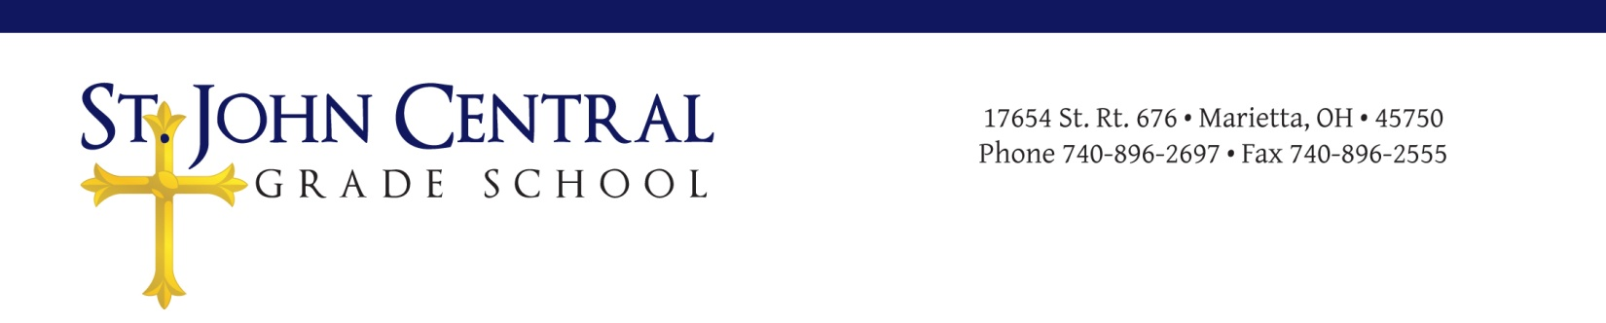

St. John Central Local Educational Advisory Council (LEAC)
Meeting Minutes
November 8, 2017

Call to Order
The meeting was called to order on Wednesday, November 8, 2017 at 7:01 p.m. in the library of St. John Central School. Followed by opening prayer and the Pledge of Allegiance. An agenda for the meeting was distributed.

Roll Call
Attendees included: Evan Schaad, Laura Schott, Ellie Tullius, and Dr. Moegling (Principal),
Kenley Schwendeman, Derek Pottmeyer, Mrs. Tomé,
Not Present: Pam Keeney, and Father Davison.

Approval of Minutes
The organizational meeting minutes of August 2, 2017, were approved.

Principal’s Report
Dr. Moegling distributed a handout outlining the topics he would be discussing. This included student enrollment for the current school year is 124 students. (24 preschool and 100 K-8). He discussed the opening of school and the success of the activities that have completed, as well as the up and coming activities; Thanksgiving Feast, November 22, Christmas program, December 6, Bishop celebrates St. Nick Day with St. John and St. Mary’s, December 7, and second grading period ends and Christmas break begins December 21. Dr. Moegling also presented a rough draft of the VIP point proposal. Ohio Department of Education inspection went well. St. John Central School Safety Plan and St. John Central Preschool handbook revision were submitted to the ODE as a result of the inspection. He commented on handing out many non-uniform passes as a result of how well the Jr. High students are leading prayer assembly.

LEAC Members Report
Derrick Pottmeyer: Excellent year everything going well.
Mrs Tomé: Planning Stone Soup play and Thanksgiving feast for Nov. 22, discussed progress reports, report cards, and curriculum mapping.
Pam Keeney: Not present. Sent a copy of the Proposed Income for school year 2017-2018 with ‘to-date’ receipts.
Father Davison: Not present.

Unfinished Business
LEAC member’s briefly reviewed a draft of the revised VIP program Cover letter and Guidelines. This week Dr. Moegling and Michelle will review and tally VIP point sheets turned in so far. Discussed sending out a mini survey questioning parents whether they would rather pay a tuition increase or continuing multiple fundraising events. A vote was proposed to have Dr. Moegling write a rough draft of the survey.

Motion: Kenley Schwendeman
Second: Laura Schott
Vote taken; motion approved.
Dr. Moegling will present a draft of the parent survey for fundraising at the next LEAC meeting.

St. John Central School Finance Council representative from each parish to assist Pam Keeney organize the budget and finances. To meet soon.
Members: Cassie Pierce-St. Ambrose
Heather Peters-Our Lady of Mercy
Russ Lang- St. John the Baptitst
TBD-St. Bernard
Pam Keeney-Treasurer

LEAC member’s briefly reviewed the revised Preschool Handbook. All good except for a couple typos to be fixed by Dr. Moegling. The handbook was voted on for approval.

Motion: Derrick Pottmeyer
Second: Kenley Schwendenman
Vote taken; motion approved.
Revised St. John Central Preschool Parent/Guardian Handbook approved 11/8/2017 8:31pm.

New Business
Review and discuss revised safety plan. Members to come prepared with feedback on VIP cover letter.

Next Meeting: Date and Time
Wednesday, January 10, 2018 @ 6:30 p.m. School Library.
Snow day- Wednesday January 24, 2018 6:30pm.

The chair adjourned the meeting at 8:40 p.m.

