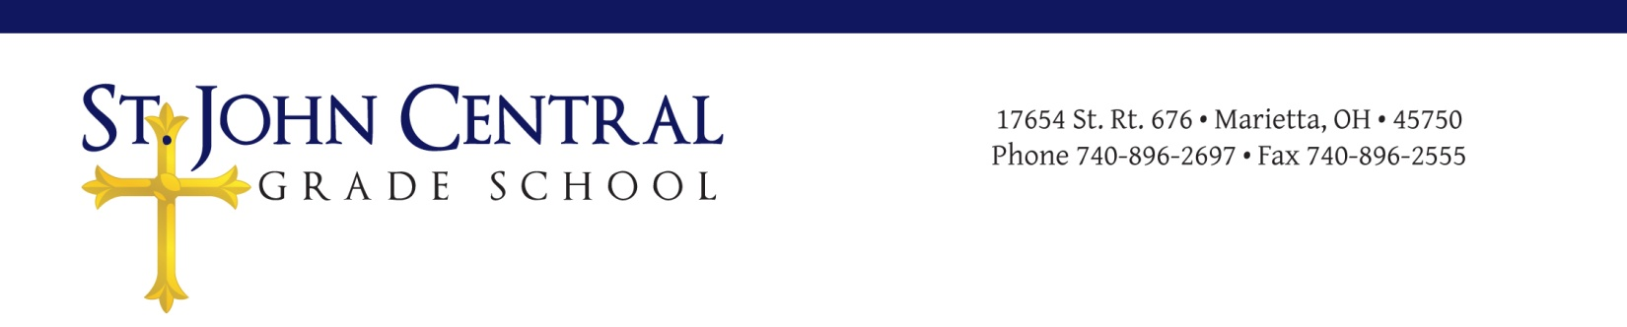
St. John Central Local Advisory Council (LEAC)
Meeting Minutes
January 10, 2018

Call to Order
The meeting was called to order on Wednesday, January 10, 2018, at 6:30 p.m. in the library of St. John Central School. Opening prayer and Pledge of Allegiance were led by Mr. Schaad, council chair. An agenda for the meeting was distributed.

Roll Call
In attendance were Evan Schaad (Chair), Dr. Moegling (Principal), Derek Pottmeyer( Home/& School), Pam Keeney (Treasurer),and Paulette Tomé (Teacher Rep).
The members who were excused included Laura Schott, Ellie Tullius, Kenley Schwendeman, and Father Davison.

Approval of Minutes
The meeting minutes of November 8, 2017l were approved.
Motion: Derek Pottmeyer
Second: Evan Schaad
Vote taken: motion approved

Principal’s Report
Dr. Moegling distributed a handout which addressed the following items:
- Make-up schedule for snow days and completion of Blizzard Bags when assigned.
- Surveys are being prepared to be sent out for the OCEA Accreditation to discern areas of weakness and define the academic goal.
- Other information listed were dates for distribution of report cards, Spelling Bee, Sub Sale, and National Catholic Schools and Diocesan Weeks (Bishop Monforton on April 17).
- Also discussed was the necessity to develop a marketing plan to promote St. John Central School noting there is area competition and St. John tuition. It was suggested to begin investigation into professional marketing. Suggestions should be directed to Pam Keeney.
- The school safety plan was approved by the ODE, and the staff handbook was distributed for review to be approved at the next meeting.
- In addition, the Daily Attendance Homework & Makeup Assignments to the classes is working well.
- Discussion regarding changing the Alumni Appeal Letter to St. John Central Annual Appeal Letter
- The VIP program and a proposed survey.

LEAC Members’ Reports
Derek Pottmeyer: The Home & School Assn. is approving the biennial transfer of funds, has one more main fundraiser, and asked for a wish list from Dr. Moegling of school needs.
Mrs. Tomé: Presented a plan to address a “disconnect” with the four parishes via periodical news to inform of school activities. Plans are in process for National and Diocesan Catholic Schools Weeks.
Mrs. Keeney: Distributed the Proposed Income for School 2017-2018 and receipts, expressed concern about the Annual Appeal, rentals for doing well, unexpected income from Grand Central Mall, and reimbursements/deposits.
Father Davison (via email): Enjoys visiting and teaching the children, good Advent Penance Service, hopes to do a Latin Mass for the students.

Unfinished Business
- Survey for all-day Pre-school was placed in church.
- Dr. Moegling presented draft of VIP survey for fundraising. Mr. Schaad and Mr. Pottmeyer will further edit survey for approval before Home & School presentation.

New Business
Members received copy of St. John Central School Staff Handbook (2018) to review and approve at the next LEAC meeting.

Next Meeting: Date and Time:
Wednesday, February 7, 2018 @ 6:30 p.m. in the school library. [This date has been changed to Tuesday, February 20 at 6:30 p.m.]

The chair adjourned the meeting at 8:30 p.m.

Respectfully submitted,

Paulette Tome’
Acting Secretary

