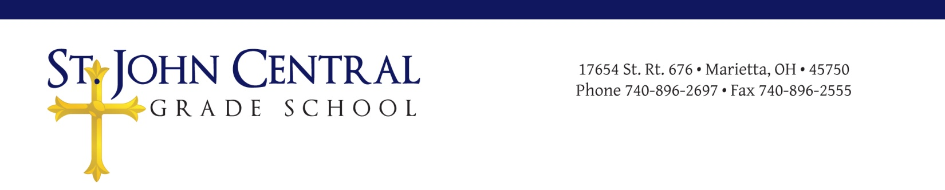

St. John Central Local Educational Advisory Council (LEAC)
Meeting Minutes
August 2, 2017

Call to Order
The meeting was called to order on Wednesday, August 2, 2017 at 7:00 p.m. in the library of St, John Central School. Followed by opening prayer and the Pledge of Allegiance.

Roll Call
Attendees included Evan Schaad, Laura Schott, Ellie Tullius, and Dr. Moegling (Principal),
Kenley Schwendeman, Derek Pottmeyer, Mrs. Tomé, Pam Keeney, and Father Davison.

Approval of Minutes
The organizational meeting minutes of June 8, 2017, were tentatively approved.

Principal’s Report
Dr. Moegling distributed an agenda for the meeting that briefly discussed the evening’s goals. He discussed the changes in staff for the 2017-18 school year. New staff members Kayla Dixon (6,7,8th grade math), and Jill Spindler (title one aid from Fort Frye). Student enrollment for 2017-18.

LEAC Members Report
Derrick Pottmeyer: Home and School Association restructured fundraising. Discussed upcoming fundraisers. Braves Bash and Mum Sales.
Mrs Tomé: Looking forward to school starting.
Pam Keeney: Questioned what kind of financial report she needed to present at LEAC meetings. Making sure we are on budget.
Father Davison: Spoke about his background and his previous Parish. Discussed meeting the other priests and deciding on a pastoral administrator.

Unfinished Business
LEAC member’s briefly reviewed the proposed St. John Central School LEAC Constitution for the new members. The constitution was then voted on for approval.

Motion: Laura Schott
Second: Ellie Tullius
Vote taken; motion approved.
The Constitution of St. John Central School Local Education Advisory Council approved at 7:50pm.
A brief review of the proposed 2017-2018 Student/Parent Handbook. Handbook then voted on for approval.

Motion: Mrs. Tomé
Second: Kenley Schwendenman
Vote taken: motion approved.
The St. John Central School Studen/Parent Handbook 2017-2018 was approved at 8:34pm.

Discussion concerning VIP points, Bingo, and communication concerning VIP points.
Dr. Moegling proposed for all families to start 2017-18 school year with clean slate, and that the VIP points system becomes the responsibility of the school office (He and Michelle S.).

Motion: Ellie Tullius
Second: Derek Pottmeyer
Vote taken: motion approved at 8:45pm.

New Business
Discuss St John Central Finance Council, 3-4 members, including Treasurer, Priest, and Principal. Parish Priests’ to nominate individual for council and have in place by end of Septmeber.

Next Meeting: Date and Time
Wednesday, November 8, 2017 @ 7:00 p.m. School Library.

The chair adjourned the meeting at 8:50 p.m.

Secretary |  | Date of Approval

Chair |  | Date of Approval

