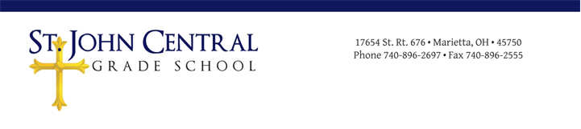Non-Prescription Medication Dispensing Form
Dear Parent/Guardian,
As directed by the Steuvenville Diocesan office, schools must obtain written permission from parents allowing us to give any medications, including over the counter (OTC) medications. Without written permission, no over the counter medications will be dispensed to a student during school hours.
If your child will need any OTC medications on a regular basis, we will need a physician’s approval. Please complete this form if you request for your child to receive any of the non-prescription medications listed below during school hours.
Acetaminophen (Tylenol):
Ibuprofen (Motrin):
Antacids (Tums):
Anti-itch cream (Cortizone-10):
Cough drops:
Other:
Name of Student:
Grade:
Date of birth:
Allergies:
We have these items on stock in the nurses office, however if there is something that your child may need on a regular basis, please send the medication into office with the original container with dosage information. We will only provide the medication listed, and manufacture’s instructions will be followed.
Please regard my signature as assurance that I release St. John Central School and any of the school’s officers/employees from liability resulting from the consequences or adverse reactions of my child taking or failing to take this medication. If applicable, parent or guardian contact will be attempted before medication is administered.
Signature of Parent/Guardian_______________________________________ Date_____________
Daytime Phone Number

